Given a number N, return true if and only if it is a *confusing number*, which satisfies the following condition:

We can rotate digits by 180 degrees to form new digits. When 0, 1, 6, 8, 9 are rotated 180 degrees, they become 0, 1, 9, 8, 6 respectively. When 2, 3, 4, 5 and 7 are rotated 180 degrees, they become invalid. A *confusing number* is a number that when rotated 180 degrees becomes a **different** number with each digit valid.

**Example 1:**

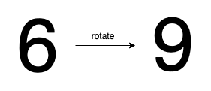

**Input:** 6

**Output:** true

**Explanation:**

We get 9 after rotating 6, 9 is a valid number and 9!=6.

**Example 2:**



**Input:** 89

**Output:** true

**Explanation:**

We get 68 after rotating 89, 86 is a valid number and 86!=89.

**Example 3:**



**Input:** 11

**Output:** false

**Explanation:**

We get 11 after rotating 11, 11 is a valid number but the value remains the same, thus 11 is not a confusing number.

**Example 4:**

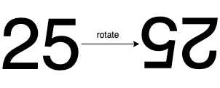

**Input:** 25

**Output:** false

**Explanation:**

We get an invalid number after rotating 25.

**Note:**

1. 0 <= N <= 10^9
2. After the rotation we can ignore leading zeros, for example if after rotation we have 0008 then this number is considered as just 8.